I have installed ubuntu

1. Installing jdk/jre on ubuntu

Installing the default jdk/jre

To do this we have to first update the package index, for that

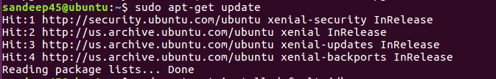

Install JDK

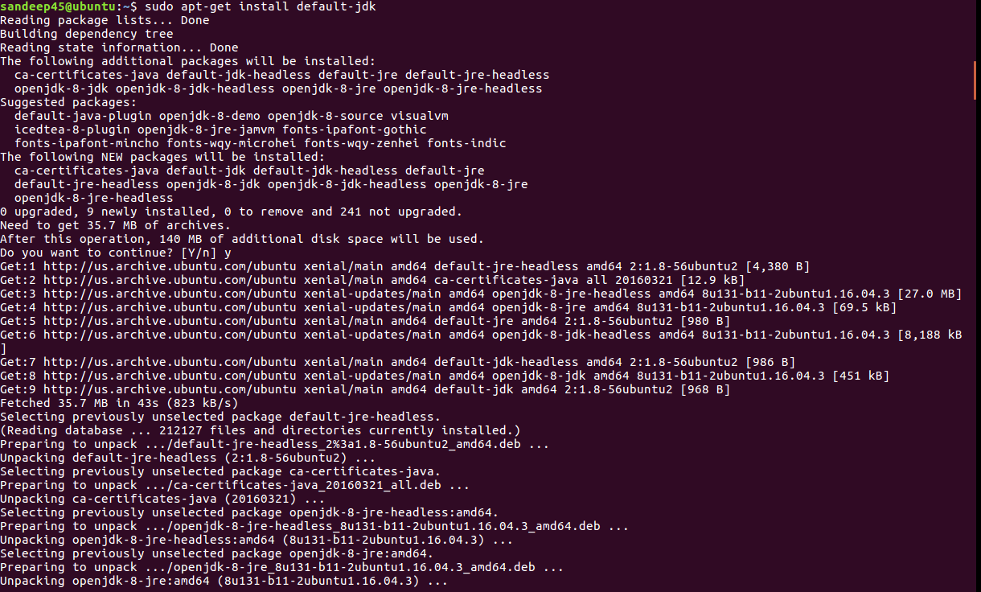

To install the official version of JDK from oracle

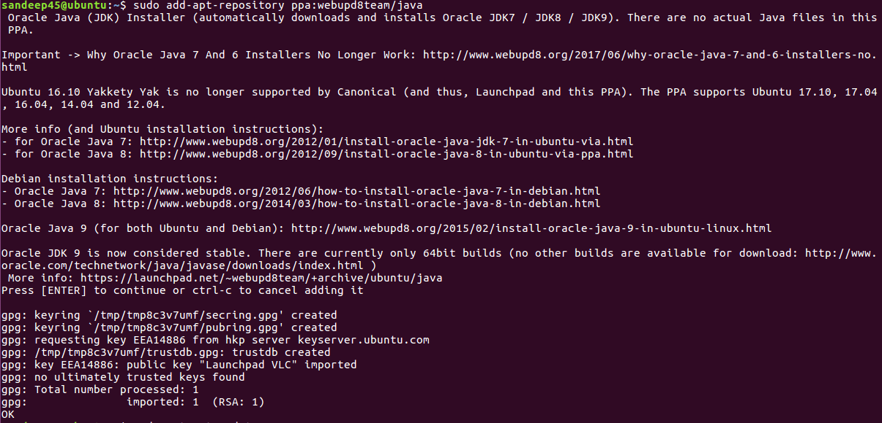

To install the jdk 9

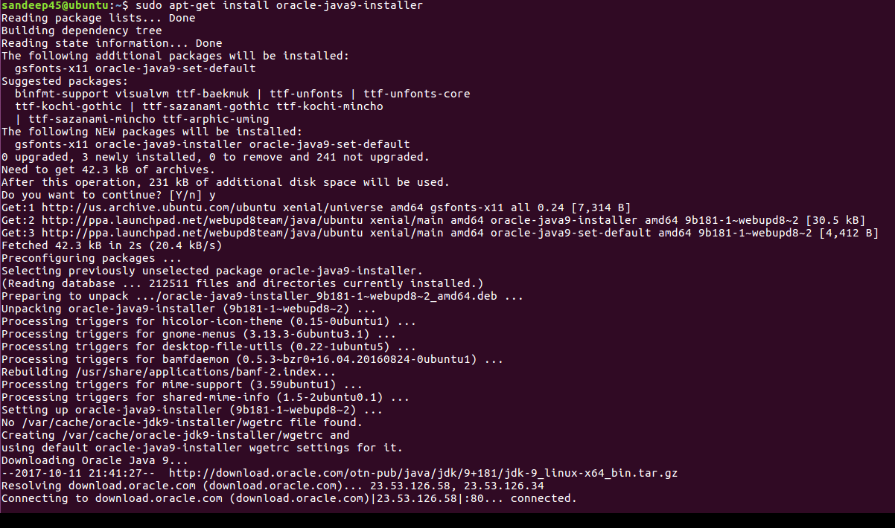

There are multiple java installations on one server, we have to set to the default.

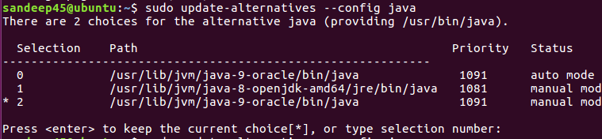

Setting up the java at home environment

